**Yellowstone National Park Page**

**Photos -** Old faithful - volcano mud pots, bison(hayden Valley), elk, Grand prismatic, Yellowstone falls

Focus of page - Lower loop sites

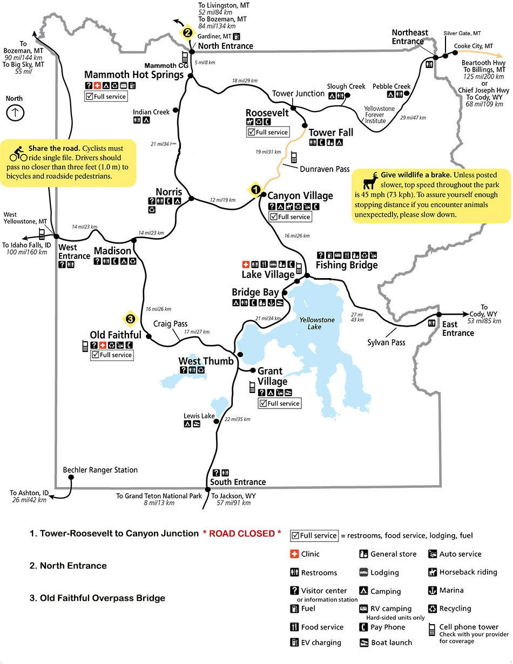

**Season-** May 15th through October 31st

**Intro -**

Yellowstone National Park is America's first and most iconic National Park.Yellowstone National Park is home to the world's largest collection of geysers and thermal feathers. It is also home to some of America's most majestic rivers and mountain ranges along with a wide diverse array of wildlife. Whether you are visiting thermal features like Old Faithful, the Norris geyser basin, Grand prismatic and Mammoth Hot Springs or Yellowstone falls and yellowstone lake you will not be disappointed with the wide variety of natural wonders and wildlife. With so many things to see and do Teton Tour Guides can help you get the most of your visit into Yellowstone national park. With a comfortable van and expert guide Teton Tour Guides can help you get the most out of your visit whether it's a full day lower loop tour or a multi day tour Teton Tour Guides makes it easy for you to focus on having a trip of a lifetime experiencing such sites as:

West thumb Geyser area

Mud Volcano

Hayden Valley-

Grand Canyon of the Yellowstone- Yellowstone river

Yellowstone Lake

Norris Geyser Basin -

Artist Paint pots -

Grand Prismatic and Midway Geyser -

Old faithful -

Hayden Valley - wildlife wolf, bison, bear and more…

Lamar valley - Bison, bear, elk, deer and more…

Mammoth hot springs

And more…

**Lower Loop Van tour -**

**Season -**  May 15th through October 31st

**Discription-**

In the lower loop of Yellowstone National Park you will experience one of the iconic day van tours in our National parks system. You will experience the classic highlights of Yellowstone National Park in one day. This tour is the best way to see as much as possible while only spending a day in the park. From Jackson Hole we will be traveling through Grand Teton National Park on our way to Yellowstone National Park. While traveling through Grand Teton National Park you will stop at Oxbow Bend, one of Grand Teton National parks most iconic views. After a quick stop you will head into Yellowstone National Park entering the lower loop of Yellowstone From the south entrance and circling the lower loop experiencing as many of the iconic sites as possible. One of the nice things about an intimate van tour with Teton Tour Guides is you can adjust on the fly depending on your interest and time availability. The typical day starts early @ 7am and is about a 12 hour experience. So be prepared for a big day in the Park. We will take care of all the details like food, snacks, logistics and the guide. Be prepared to take lots of photos and walking at some different sites. So be prepared with extra layers and comfortable shoes.

**Cost -** $1650.00 includes 4 guests $325.00 per person after that max 8 guests.

Meeting time 7am drop off time 7pm

Season dates - May15th through October 31st

**Included in your experience**  - The cost includes Coffee, breakfast snacks, Lunch transportation and guide for the day. Hotel/ or meeting place pick up and drop off.

Cameras with high power lenses

Spotting scope and binoculars

Lunch

Snakes and waters

**Not Included in the tour -**

Parks entrance fees

SD card for camera

Guide Gratuity

**Visit the loop of yellowstone including stops like:**

Along with all the natural wonder sites we will also be encountering a lot of wildlife. Although there are no guarantees to see wildlife, Yellowstone is known for its habitat for wildlife such as Bears, Bison, wolf, eagles, elk, deer. Owls and many others.

Join an experienced guide on a wildlife safari tour of Yellowstone National Park. We will focus on the geology, wildlife, and natural history of [Yellowstone National Park](http://www.nps.gov/yell/index.htm) while customizing the tour around your specific areas of interest. We will start the day by traveling north through [Grand Teton National Park](http://www.nps.gov/grte/index.htm) entering Yellowstone through the South Entrance. We then travel around the entire “lower loop” road visiting famous Yellowstone features like the [Continental Divide](http://en.wikipedia.org/wiki/Continental_Divide_of_the_Northern_Americas), Old Faithful, Fountain Paint Pots, the Grand Canyon of the Yellowstone, Hayden Valley, Mud Volcano, [Yellowstone Lake](http://www.tripadvisor.com/Attraction_Review-g60999-d140435-Reviews-Yellowstone_Lake-Yellowstone_National_Park_Wyoming.html) and much more. Wildlife will also be a priority as we travel through the park with opportunities to see moose, elk, deer, bison, pronghorn, fox, coyote, bald and golden eagles, black bears, grizzly bears and even wolves depending on season. Your knowledgeable guide will make frequent stops as opportunities for wildlife viewing present themselves. The route each day will vary depending on wildlife, group interest and road conditions.

**TTG Yellowstone upper loop page**

Photos Mammoth terrace - Fort yellowstone - Liberty Cap - Steamboat Springs - Bison - Elk - Upper lower Yellowstone falls

Map of the upper loop showing stops

**Description -** The Upper Loop of Yellowstone National Park is one of the iconic day trips in Yellowstone. Unfortunately we cant cover all of the highlights of Yellowstone National Park on this trip. This is a good option for those who have seen the lower loop and want to experience more of the park. From Jackson we will be traveling through Grand Teton National Park on our way to Yellowstone National Park. you will travel the lower loop entering Yellowstone From the south entrance and circling the lower loop Bypassing the usual site and head north. There is not enough time in one day to stop at the sites of the lower loop and still make it to the north entrance and the Roosevelt Arch and be able to spend time at Mammoth Hot Springs, one of Yellowstone's most spectacular sites. Explore the Historic Fort Yellowstone and the Albright visitor center. One of the nice things about a private intimate tour with Teton Tour Guides is we can adjust on the fly depending on your interest and time availability. The typical day starts early @ 7am and is about a 12 hour experience. So be prepared for a big day in the Park.

Visit the upper loop of yellowstone including stops like:

Sheep Eaters Cliffs

Historic Fort Yellowstone - Fort Sheridan -

Albright Visitor Center

Liberty Cap -

Rosevelt Arch - North entrance

Mammoth Hot Springs

Grand Canyon of the Yellowstone-

Along with all the natural wonder sites we will also be encountering a lot of wildlife. Although there are no guarantees to see wildlife, Yellowstone is known for its habitat for wildlife such as Bears, Bison, wolf, eagles, elk, deer. Owls and many others.

**Cost -** Minimum of 4 guests @ $425.00 per person $325.00 per person after that max 13 guests.

Meeting time 7am drop off time 7pm

**Includes -** The cost includes Coffee, breakfast snacks, Lunch transportation and guide for the day. Hotel/ or meeting place pick up and drop off.

Does not include - Parks entrance fees

Camera’s

Spotting scope and binoculars