TTG Yellowstone Lower loop page

Photos - Old faithful - volcano mud pots, bison(hayden Valley), elk, Grand prismatic, Yellowstone falls

Focus of page - Lower loop sites

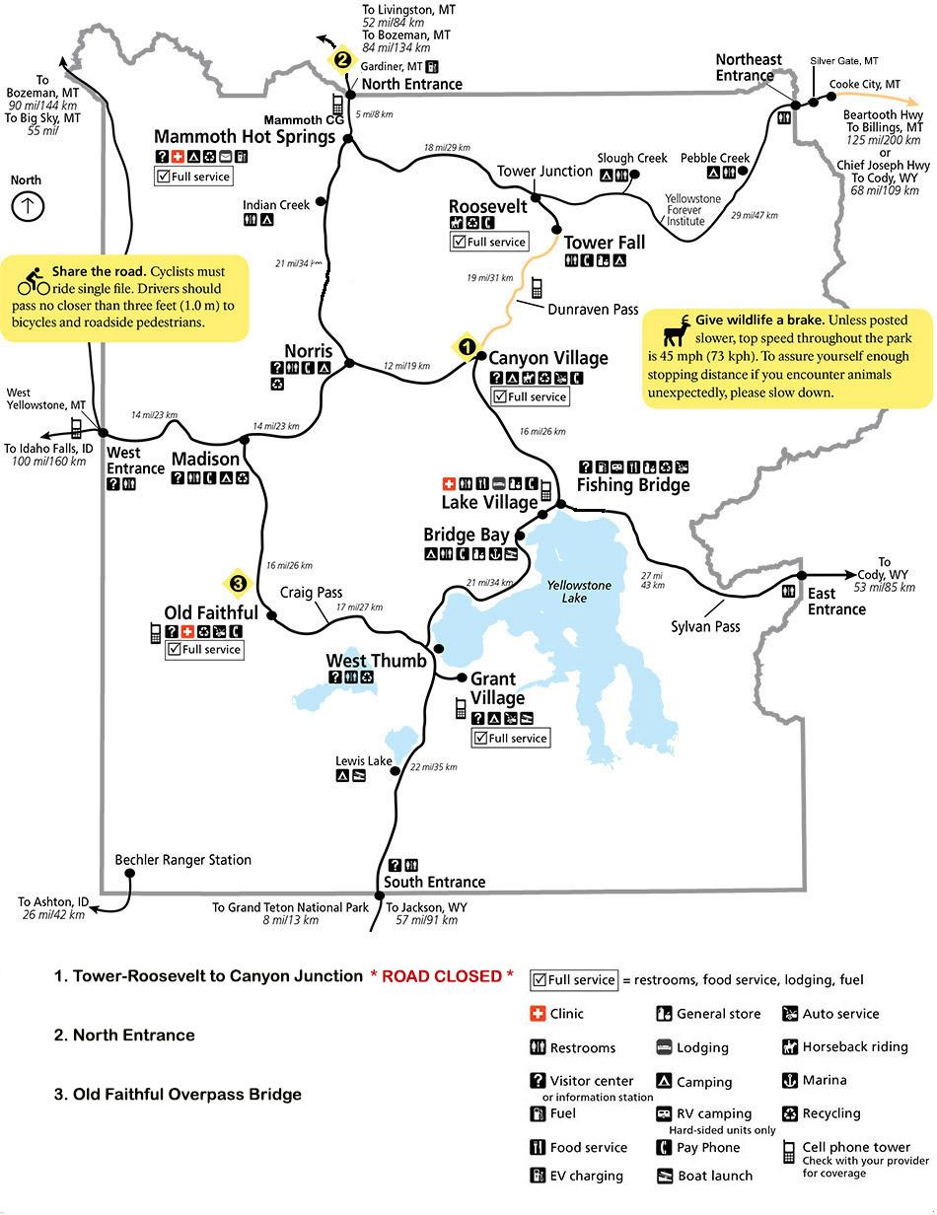

Season May 15th through October 31st

**Intro -**

In the lower loop of Yellowstone National Park you will experience one of the iconic day van tours in our National parks system. You will experience the classic highlights of Yellowstone National Park in one day. This tour is the best way to see as much as possible while only spending a day in the park. From Jackson Hole we will be traveling through Grand Teton National Park on our way to Yellowstone National Park. While traveling through Grand Teton National Park you will stop at Oxbow Bend, one of Grand Teton National parks most iconic views. After a quick stop you will head into Yellowstone National Park entering the lower loop of Yellowstone From the south entrance and circling the lower loop experiencing as many of the iconic sites as possible. One of the nice things about an intimate van tour with Teton Tour Guides is you can adjust on the fly depending on your interest and time availability. The typical day starts early @ 7am and is about a 12 hour experience. So be prepared for a big day in the Park. We will take care of all the details like food, snacks, logistics and the guide. Be prepared to take lots of photos and walking at some different sites. So be prepared with extra layers and comfortable shoes.

**Cost -** $1650.00 includes 4 guests $325.00 per person after that max 8 guests.

Meeting time 7am drop off time 7pm

Season dates - May15th through October 31st

**Included in your experience**  - The cost includes Coffee, breakfast snacks, Lunch transportation and guide for the day. Hotel/ or meeting place pick up and drop off.

Cameras with high power lenses

Spotting scope and binoculars

Lunch

Snakes and waters

**Not Included in the tour -**

Parks entrance fees

SD card for camera

Guide Gratuity

**Visit the lower loop of yellowstone including stops like:**

West thumb Geyser area

Mud Volcano

Hayden Valley-

Grand Canyon of the Yellowstone-

Norris Geyser Basin -

Artist Paint pots -

Grand Prismatic and Midway Geyser -

Old faithful -

Along with all the natural wonder sites we will also be encountering a lot of wildlife. Although there are no guarantees to see wildlife, Yellowstone is known for its habitat for wildlife such as Bears, Bison, wolf, eagles, elk, deer. Owls and many others.

Join an experienced guide on a wildlife safari tour of Yellowstone National Park. We will focus on the geology, wildlife, and natural history of [Yellowstone National Park](http://www.nps.gov/yell/index.htm) while customizing the tour around your specific areas of interest. We will start the day by traveling north through [Grand Teton National Park](http://www.nps.gov/grte/index.htm) entering Yellowstone through the South Entrance. We then travel around the entire “lower loop” road visiting famous Yellowstone features like the [Continental Divide](http://en.wikipedia.org/wiki/Continental_Divide_of_the_Northern_Americas), Old Faithful, Fountain Paint Pots, the Grand Canyon of the Yellowstone, Hayden Valley, Mud Volcano, [Yellowstone Lake](http://www.tripadvisor.com/Attraction_Review-g60999-d140435-Reviews-Yellowstone_Lake-Yellowstone_National_Park_Wyoming.html) and much more. Wildlife will also be a priority as we travel through the park with opportunities to see moose, elk, deer, bison, pronghorn, fox, coyote, bald and golden eagles, black bears, grizzly bears and even wolves depending on season. Your knowledgeable guide will make frequent stops as opportunities for wildlife viewing present themselves. The route each day will vary depending on wildlife, group interest and road conditions.