Grand Teton National Park

Grand Teton National park Tours

**Sunrise and sunset tours-**

**Photos -**  Bear, Jenny Lake, elk, Moose, John Moulton Barn, deer, Grand Teton

Focus of page - Grand Teton National Park - mountains and wildlife

Map of the Grand Teton National Park

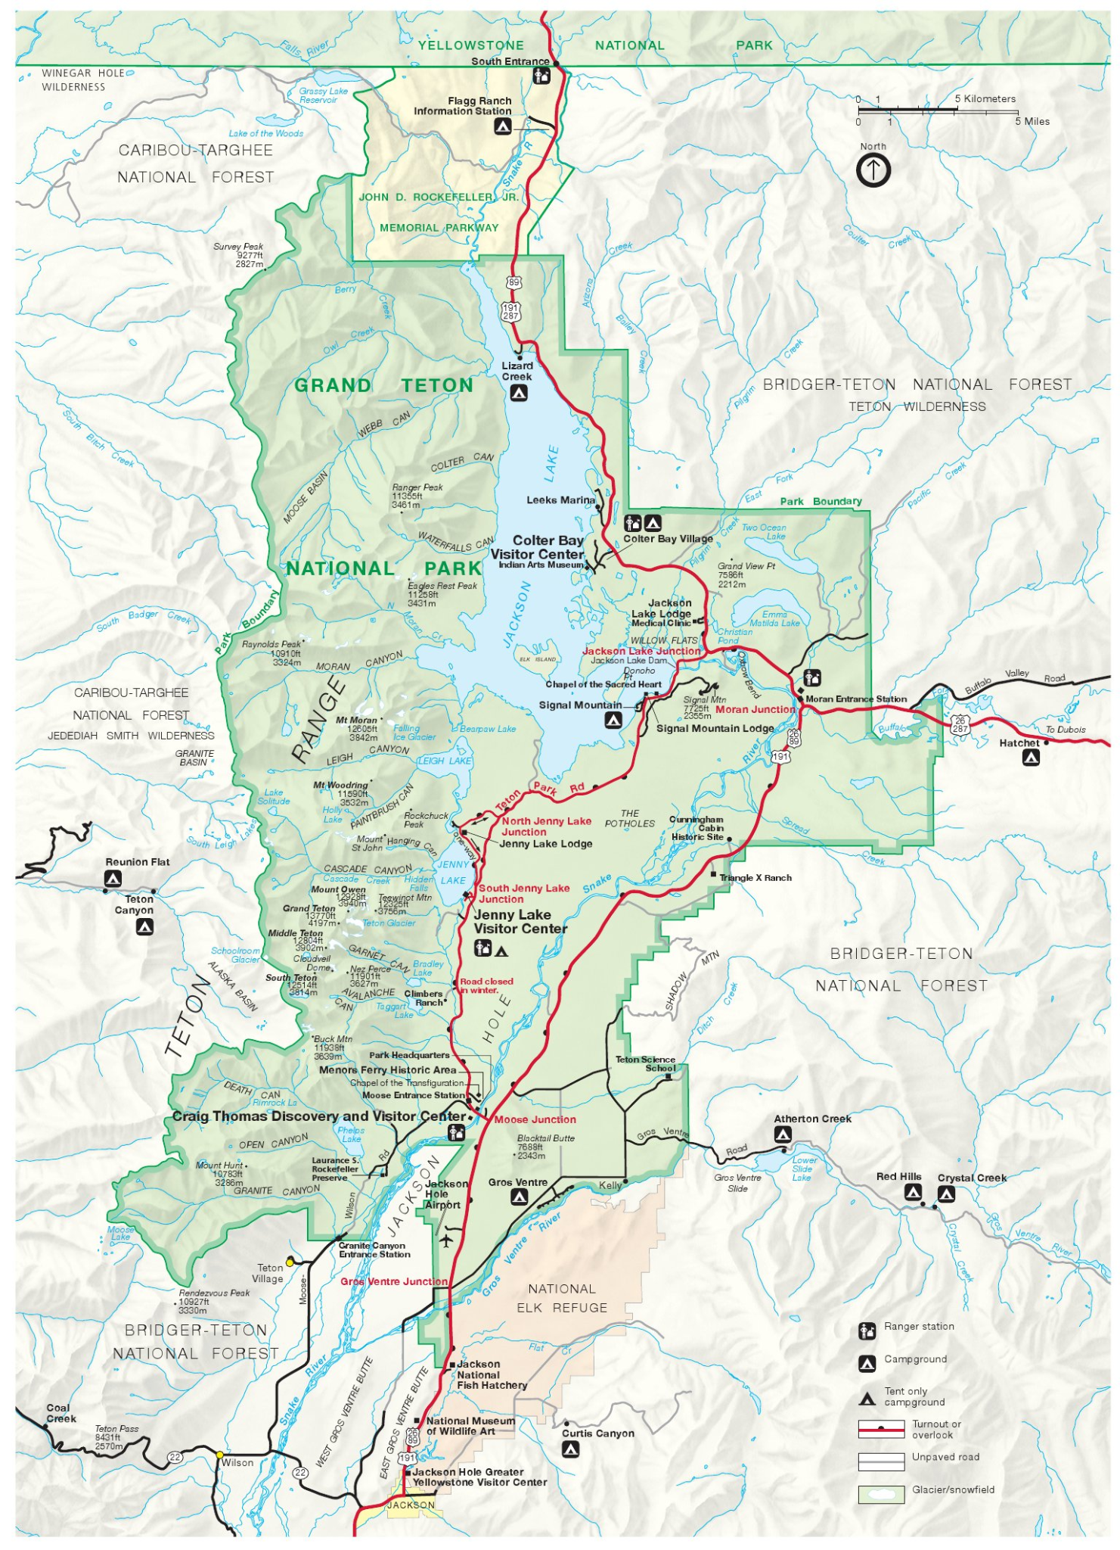

**Season** May 15th through October 31st

**Intro -**

Grand Teton National park is the best place to see wildlife and the majestic Teton Mountain Range and its lakes and surrounding valley. You will experience the classic highlights of Grand Teton National park in this ½ day(4-5hours) van tour. This tour is the best way to see as much as possible while only spending a ½ day in the park. From Jackson Hole we will be traveling through the elk refuge and moose wilson road on the way to Grand Teton National Park. While traveling through Grand Teton National Park you will stop at Oxbow Bend, one of Grand Teton National parks most iconic views along with a stop at the John Moulton Barn onne of the iconic photos in the Jackson Hole area. Along the way you will be stopping at the many scenic areas showcasing the Grand Teton and Mt Morain. One of the nice things about an intimate van tour with Teton Tour Guides is you can adjust on the fly depending on your interest and time availability. The typical day starts early @ 7am/4:30pm and is about a 4-5 hour experience. So be prepared for a fun few hours in the Park. We will take care of all the details like food, snacks, logistics and the guide. Be prepared to take lots of photos and to walk at different sites. also be prepared with extra layers and comfortable shoes. Early mornings and evenings when the sun goes down can be cooler with possibilities of weather..

***Sunset Tour -***

**Photos** - Grand Teton - bear - Elk - Moose and Jon Moulton Barn - Jenny lake -

**Intro -**

The sunset Tour of Grand Teton national Park is a wildlife and mountain viewing experience like no other. Driving along Moose Wilson Road and the park give you ample opportunity for wildlife viewing and photos of the Teton peaks:

Stopping along the way so you can enjoy the sunset and a meat and cheese platter along with wine and drinks. For those of legal age for those who don't drink alcohol we provide Jackson Hole root beer, sarsaparilla, ginger beer and of course huckleberry soda. Along with other non alcoholic beverages.

Known for its Moose, Bear and Elk population, it is the ideal area and best chance to view the many majestic animals that make the Jackson Hole and the Grand Teton National Park area so popular. It is also one of the most majestic mountain ranges you will find anywhere. With big views of the Grand Teton, the Teton Peaks Jackson Lake and Mt Moran.

**Description -** A typical tour starts at 4pm and is about a 4 hour experience. This tour includes Wine (for those of legal age) cheese and a churcurtory board with fresh bread fruit. All tours are accompanied by a professional tour guide and naturalist.

**Cost -** Minimum of 4 guests @ $175.00 per person $$95.00 per person after that max 13 guests.

Meeting time 4m drop off time 8pm

**Includes -**

Wine and cheese snacks, churcurtory board. fresh bread and fruit

Professional guide for the evening.

Hotel/ or meeting place pick up and drop off.

Use of Cameras

Use of Spotting scope and binoculars

**Does Not include -**

National parks fees

Guide gratuity

**Sunrise scenic wildlife tour** -

Photos - Grand Teton - bear - Elk - Moose and Jon Moulton Barn - Jenny Lake - sunrize Grand Teton

**Intro -**

The sunset Tour of Grand Teton national Park is a wildlife and mountain viewing experience like no other. Driving along Moose Wilson Road and the park give you ample opportunity for wildlife viewing and photos of the Teton peaks:

Stopping along the way to enjoy the sunrize and a breakfast spread including Coffee, donuts, beagles , cheese, fresh fruit, yogurt and drinks.

Known for its Moose, Bear and Elk population, it is the ideal area and best chance to view the many majestic animals that make the Jackson Hole area so popular. It is also one of the most majestic mountain ranges you will find anywhere. With big views of the Grand Teton, the Teton Peaks and Mt Moran.

**Description -** A typical tour starts at 7am and is a 4 hour experience. This tour includes Beagles, donuts, cheese, fresh fruit, yogurt, fresh juice, and local coffee. All tours are accompanied by a professional guide.

**Cost -** $695.00 for the first 4 people $95.00 per person after that.

Meeting time 7am drop off time 11am

**Includes -**

The cost includes Coffee, donuts, beagles , cheese, fresh fruit, yogurt and drinks.

Binoculars

Spotting scope

Cameras for use with high power lenses

Professional guide.

Hotel/ or meeting place pick up and drop off.

Use of Cameras

Spotting scope and binoculars

**Does not include -**

Parks entrance fees

Guide Gratuity